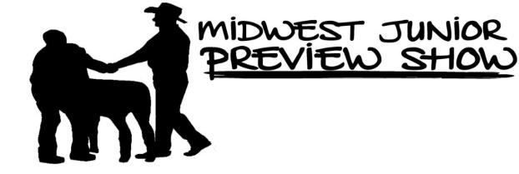
Unloading: Please unload and pen anywhere you’d like but be conservative Want to help? You can make a donation of $2 per pen to MJPS to cover your cost!
Friday, May 31
9am MJPS Board of Directors Meeting – Sheep Barn
10am – 8pm Registration/ Check in for Saturday show **ALL ANIMALS MUST BE CHECKED IN FRIDAY BY 8PM**
3pm: MJPS Board Interviews Start
6pm: MJPS Show Ring Dinner sponsored by Reproduction Specialty Group and Red Dirt Downs
7:30-9pm: Pool Party at Liberty Park Pool sponsored by Lobdell Dorpers
8pm: ALL ANIMALS MUST BE CHECKED IN
Saturday, June 1
7:00am: Class splits to be posted
7:30am: Exhibitor Photo and Meeting (Showring)
After Meeting: Donuts provided by the United Junior Suffolk Association
North Ring – Jennifer Livermore | South Ring – Jeff Held
Non-Competitive Showmanship | 8 and under showmanship
Hampshire | Tunis
Polled Dorset | Montadale
Horned Dorset | Oxford
Dorset Advantage | Katahdin
Shetland | Southdown
Rambouillet | Corriedale
Shropshire | Natural Colored
Columbia | Dorper
Suffolk | White Dorper
Cheviot | Commercial
Babydoll Southdown | Lincoln
8:00am: Breed Shows Begin **Order subject to change as breeds are added/removed

**Other breeds added to the end of the schedule as needed.
Following: Additional showmanship classes split as follows, 9-12, 13-15, 16-18, 19-21.
Parent/Child Jackpot Classes (2 breaks based on child’s age, $10 entry fee, 50% payback to 1st place)
Heartland Livestock Supreme Champion Ram and Ewe Drive
CHECKOUT – Exhibitors may check out anytime! ALL EXHIBITORS will have checks. Announcements will be made when checks are ready after breed divisions – please allow adequate time after larger divisions.
Sunday, June 2
Noon: All sheep must be out of the barn.

